E-Commerce Business Model
Data Management Project
IS680 Team 5
Report prepared by
Duyen (Julie) Nguyen, Ninh Nguyen,
Andrew Lee, Zhilu Liu, Ngoc Tang, and
Justin Huang

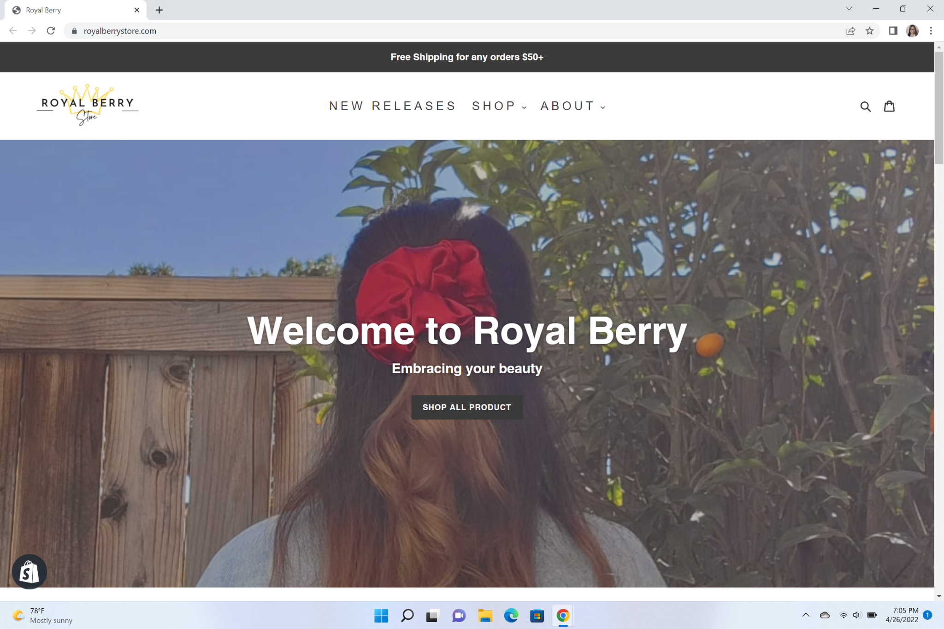

I. Introduction
The e-commerce industry has been growing rapidly in recent decades. E-commerce refers to activities of selling and purchasing goods or services over the internet. Although retail has struggled over the past few years due to the pandemic, e-commerce businesses have grown strongly during this period. As the pandemic has increased consumers' demand of shopping online, more and more online business has emerged.
Royal Berry is a small e-commerce business developed in 2021 by two CSULB graduate students. Royal Berry has a Business to Consumer Model (B2C) in which we sell our products directly to customers. Royal Berry is selling mostly customized and handmade products including printed t-shirts, hoodies, customized phone cases, and handmade scrunchies.
Since Royal Berry is a newly established business, the company needs a database system to better keep track of all information and manage the flow of the business.
Our database design for Royal Berry includes conceptual model, logical model, data dictionary, and the actual implementation of the SQL queries.

II. Conceptual Model
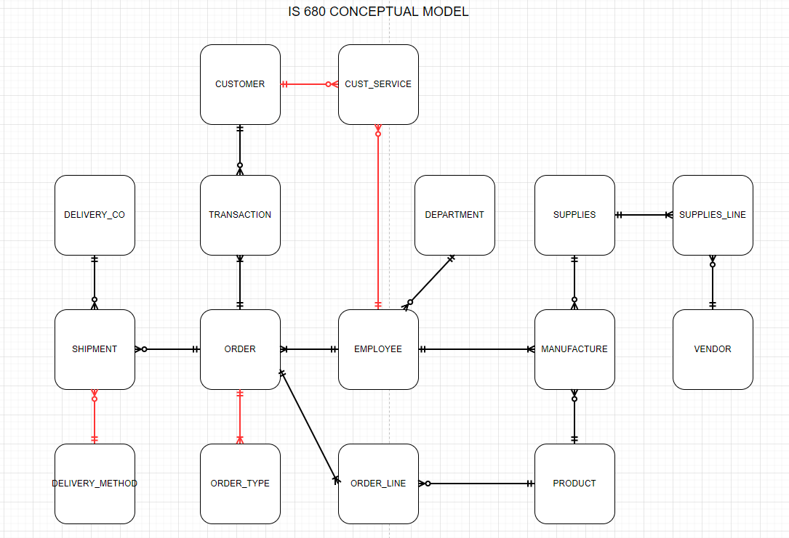
This is our conceptual model with a total of 16 entities. We have multiple relationship types between our entities: mandatory one, mandatory many, optional one, and optional many. Most of our entities have a relationship with our Order entity. This is because we are an e-commerce company so our ERD reflects the fact that we are centered around customer orders. The relationships that are highlighted in red are the entities that are events. Some of these are shipment, order, customer service, and supply order.

III. Logical Model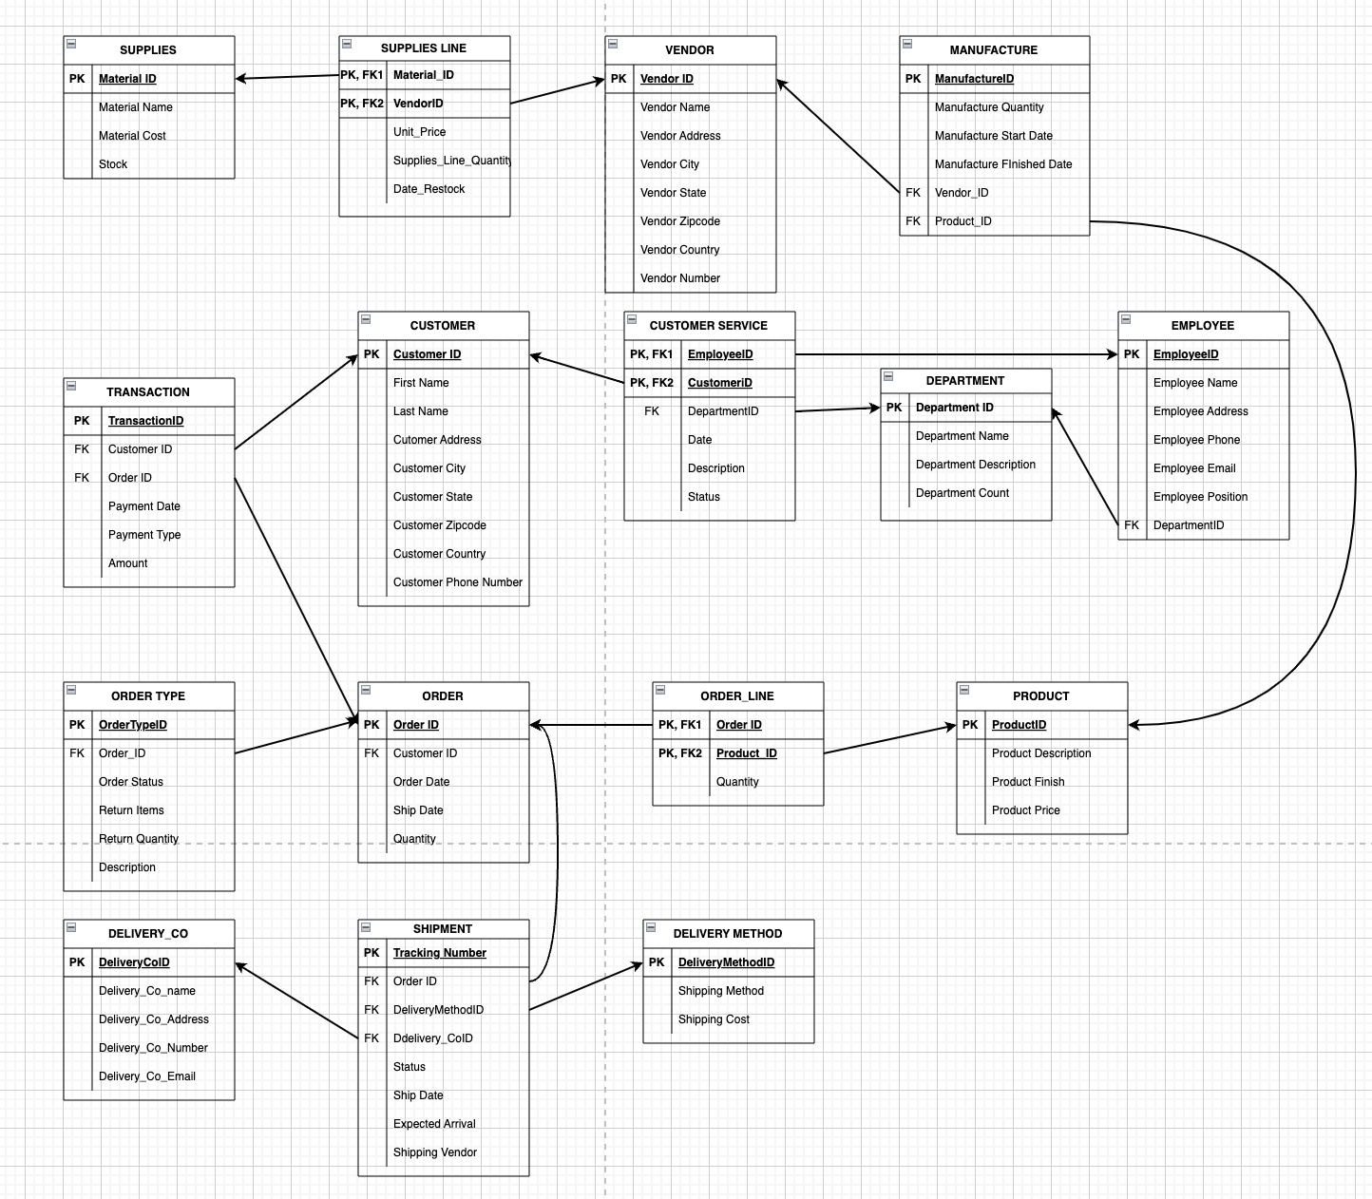

To create an actual database, we have to transform our conceptual model into a form that can maintain the data's integrity and consistency. The diagram above is our logical diagram that was transformed from the conceptual diagram in part II. Each entity in a logical diagram has a primary key which is a unique identifier of the relation. To identify the relationship between tables, we also define foreign keys. Later when we design the database, the foreign keys will also help our end-users by optimizing the process of pulling data from tables linked by foreign keys. To explain the logical diagram, we will focus on the key activities in the model. The main activities include order, shipment, and customer service.

IV. Data Dictionary
http://localhost/phpMyAdmin/db_datadict.php?db=finaldata&goto=db_structure.php
This link will take you to a page with the data dictionary. A MAMP connection is required.

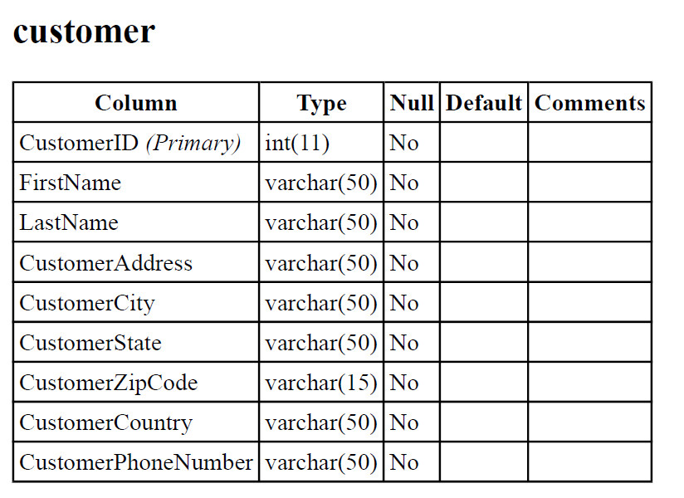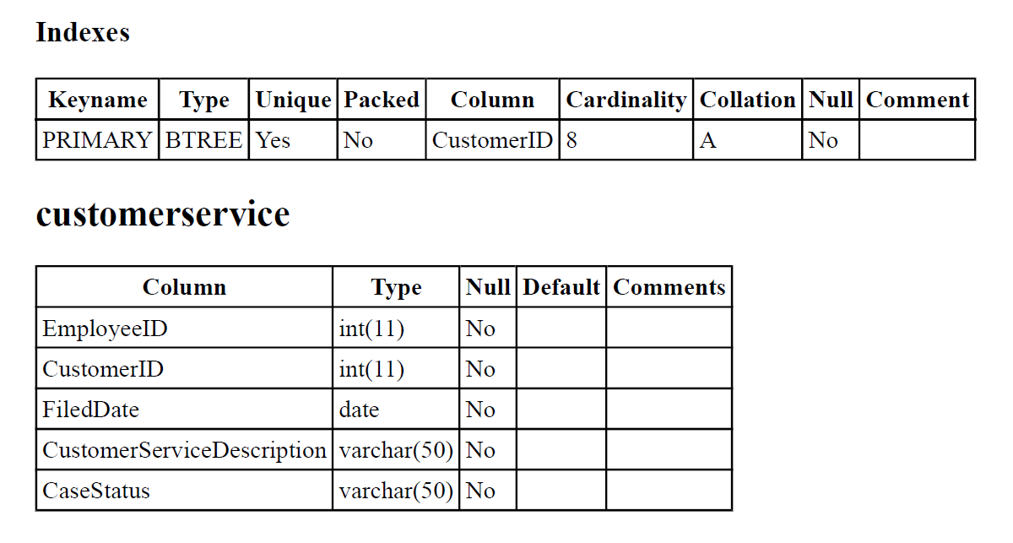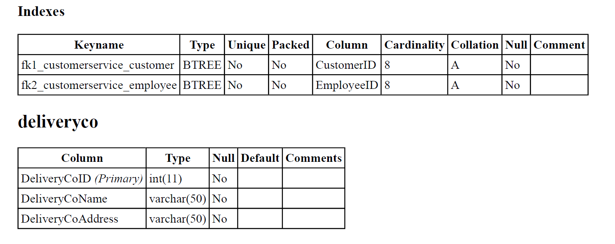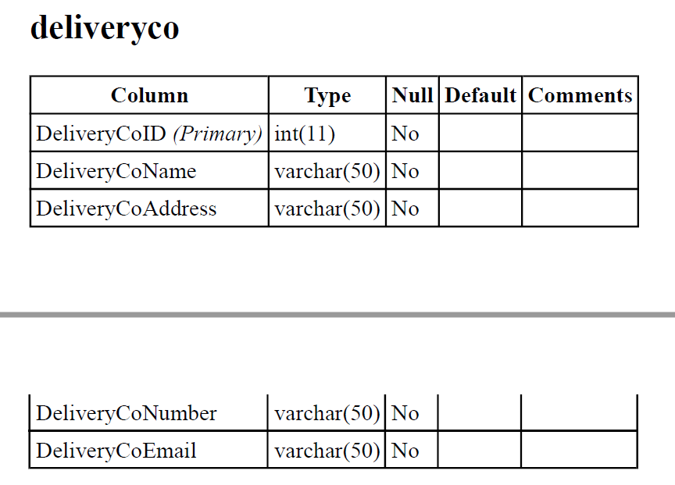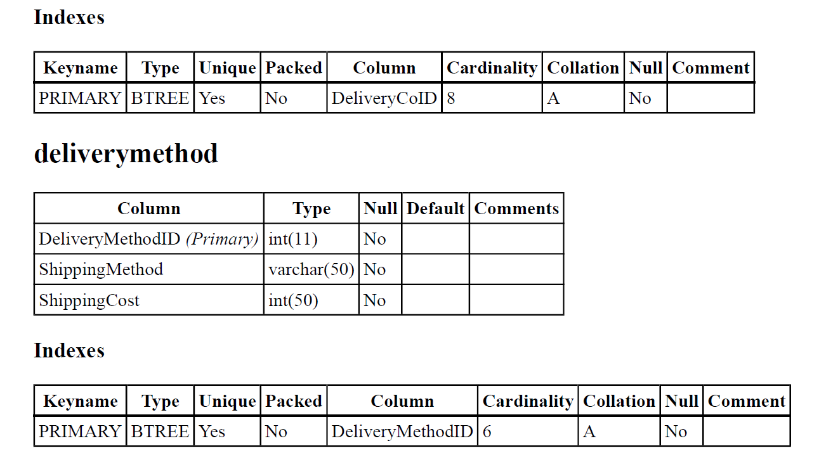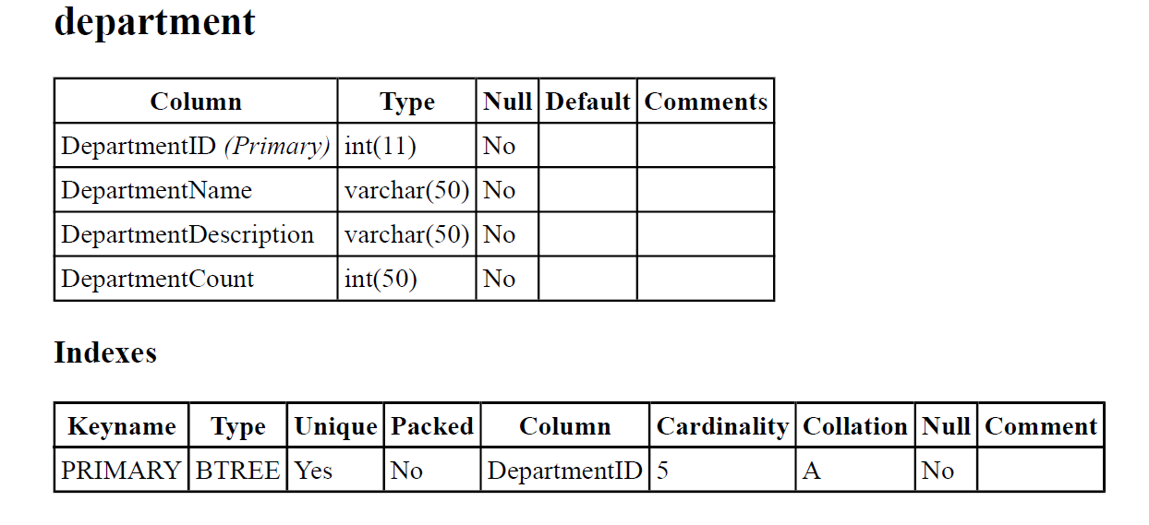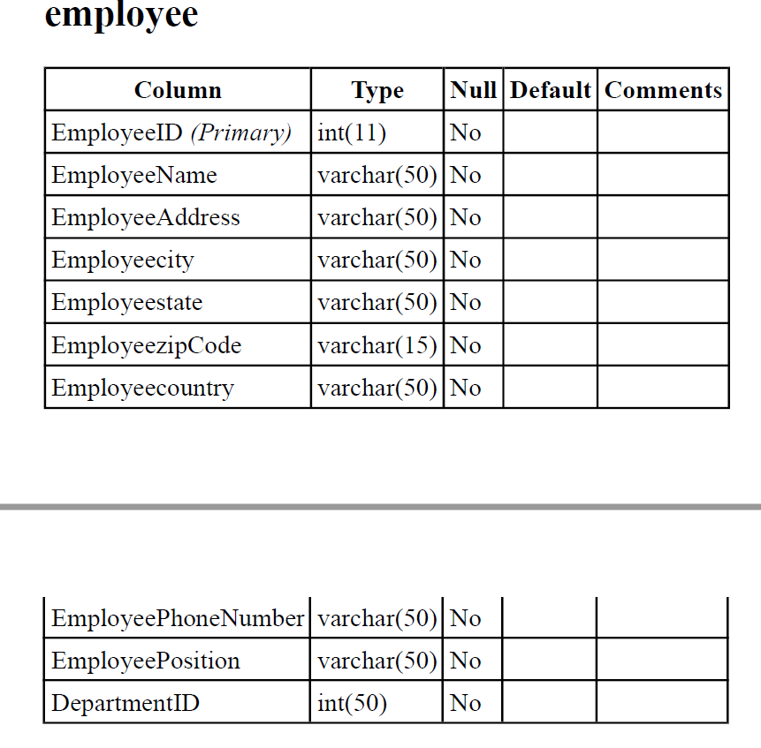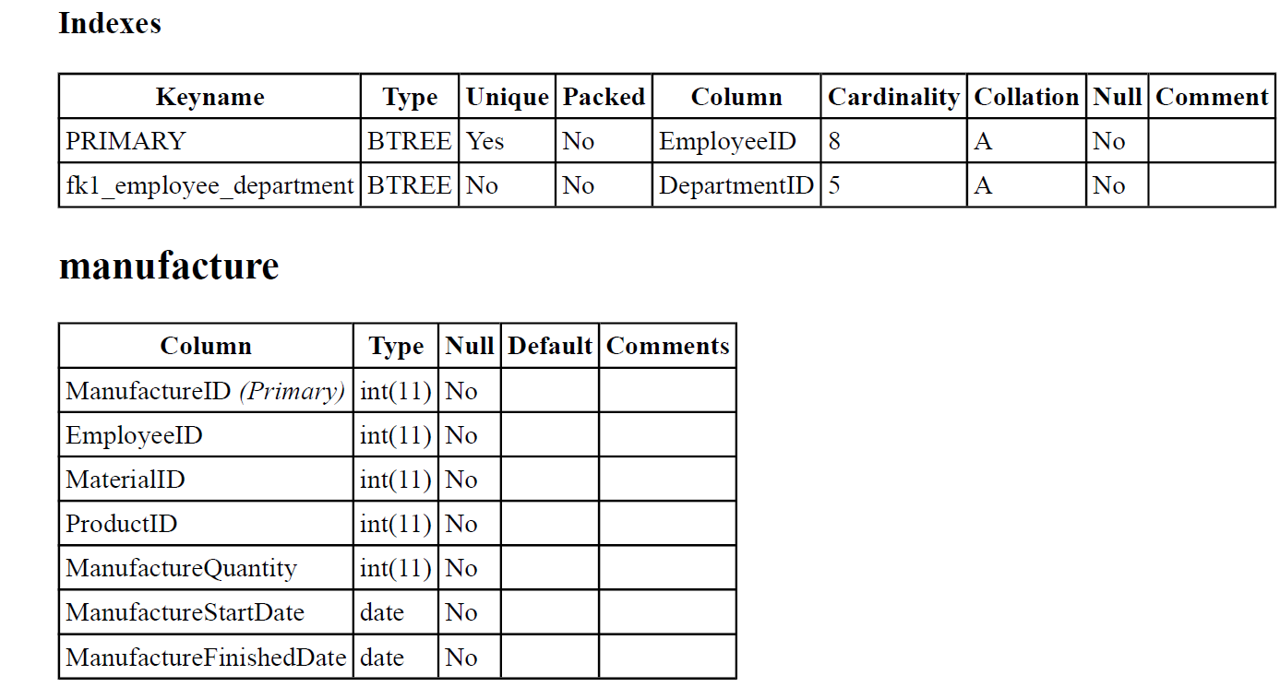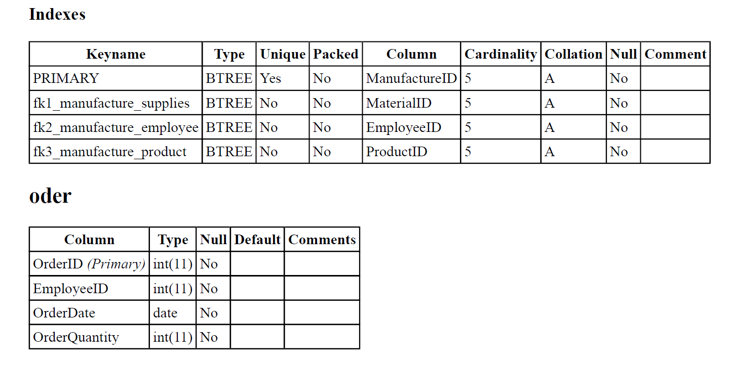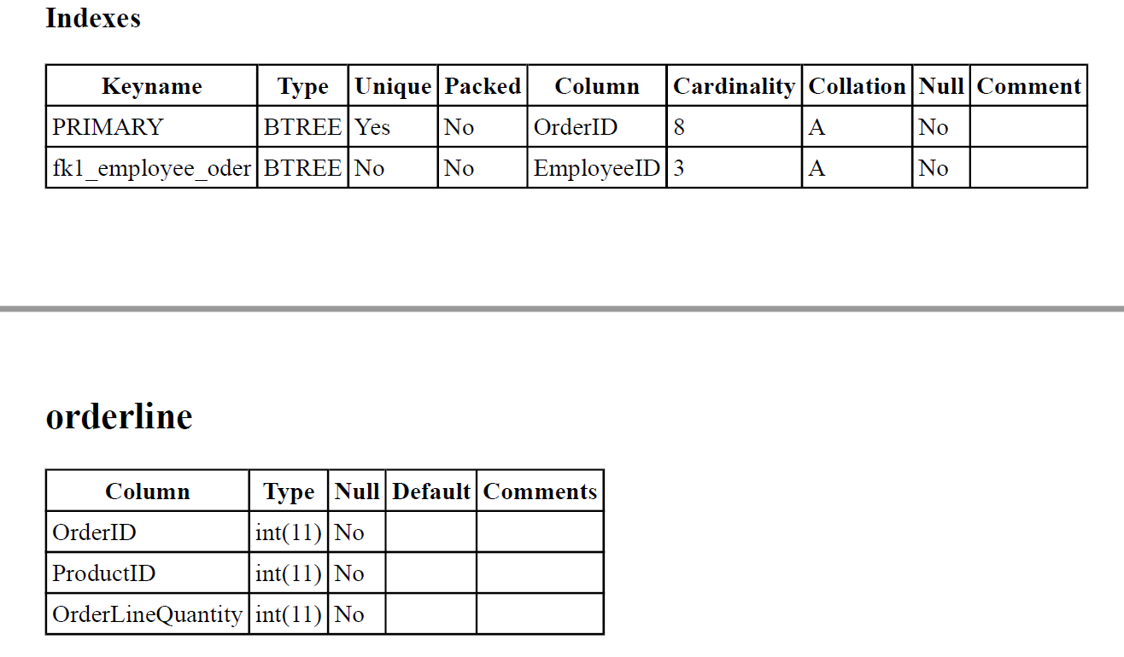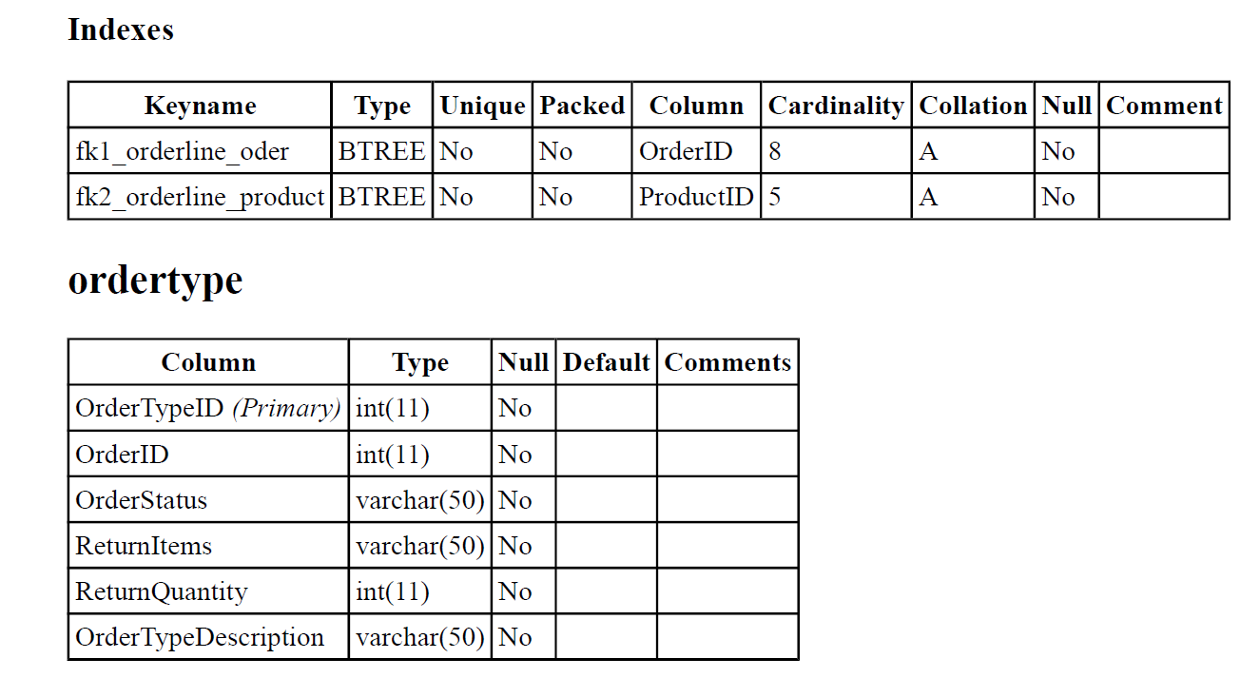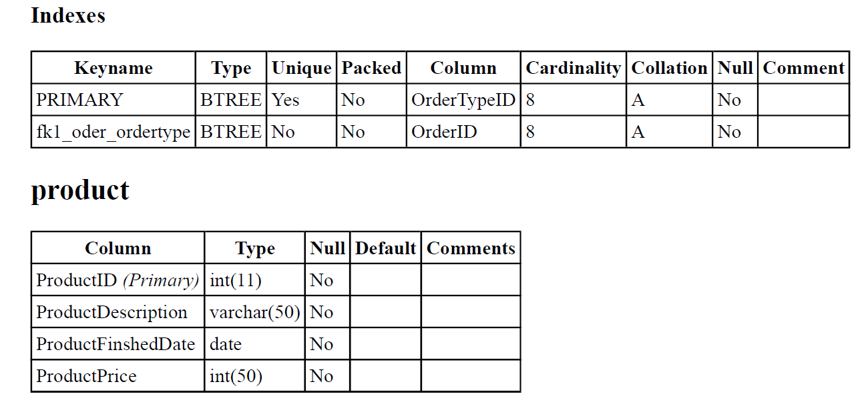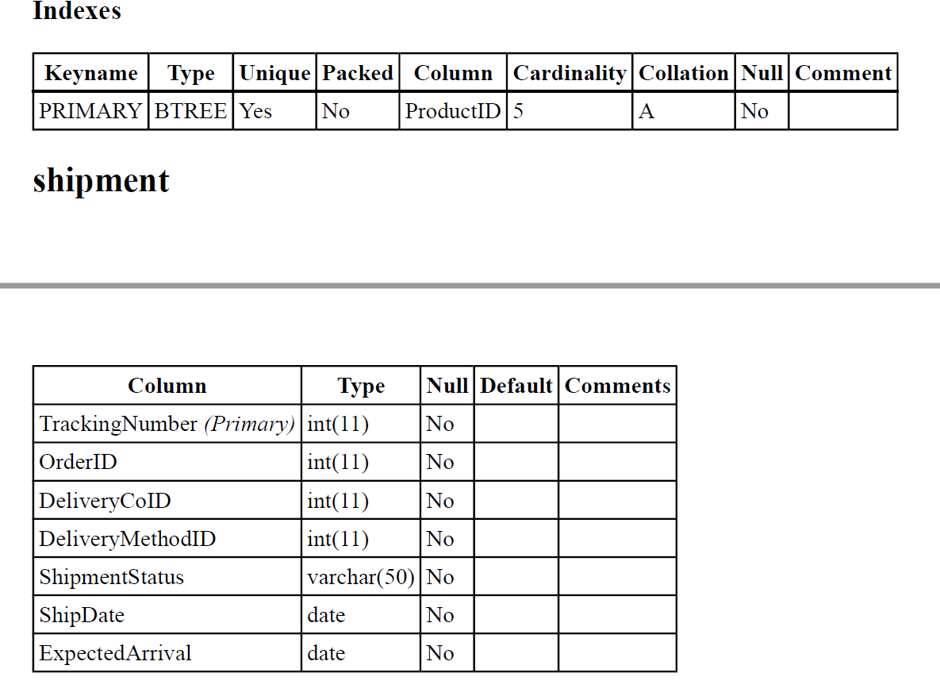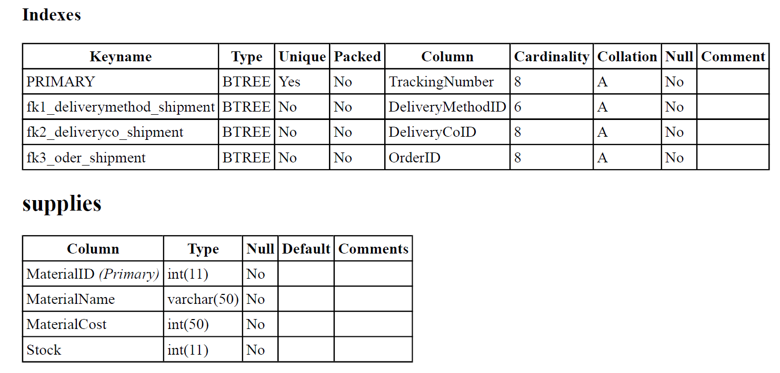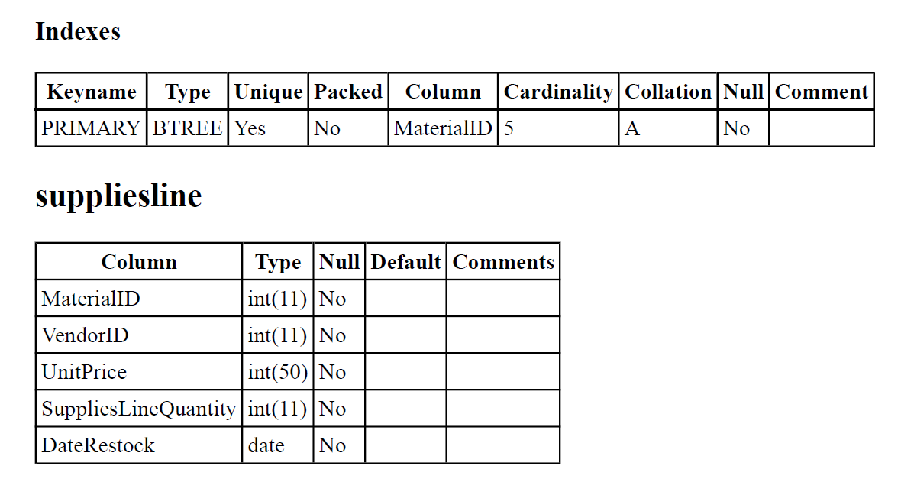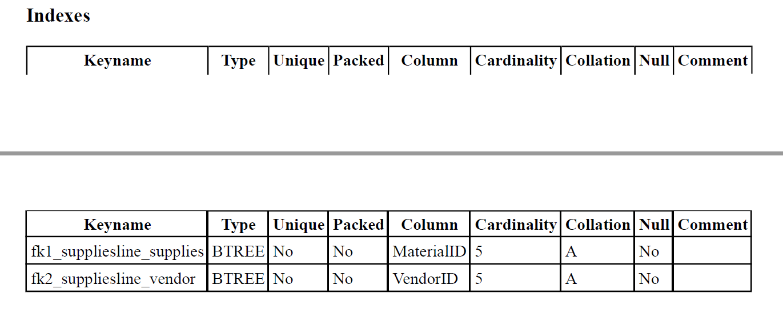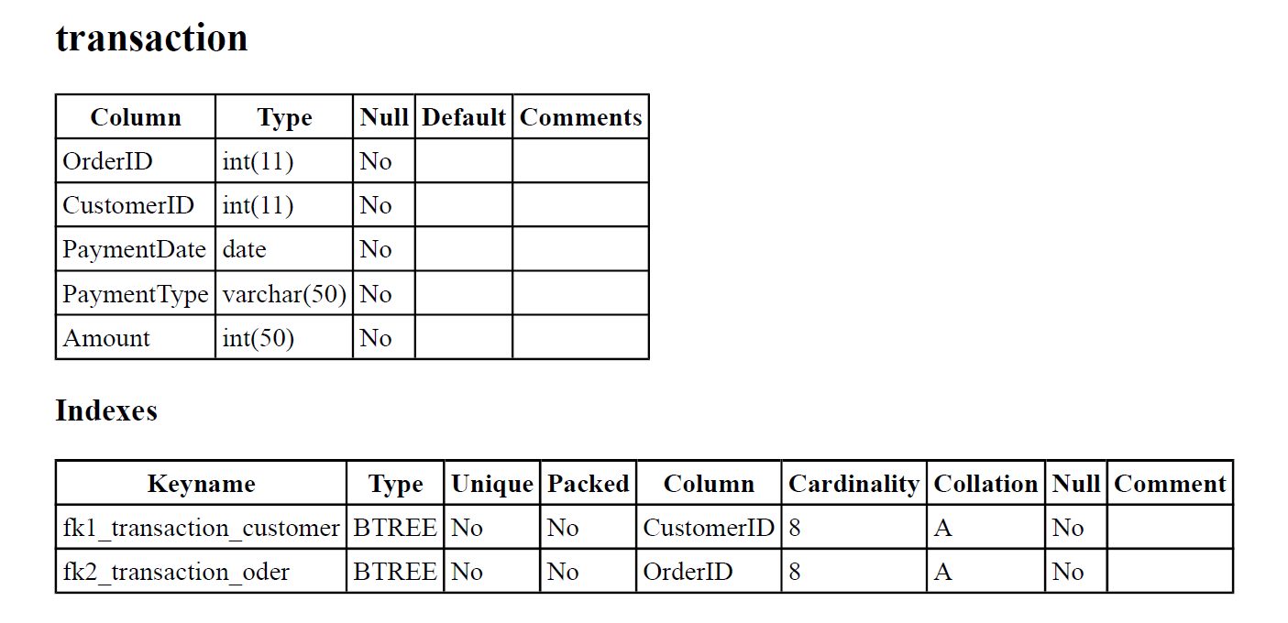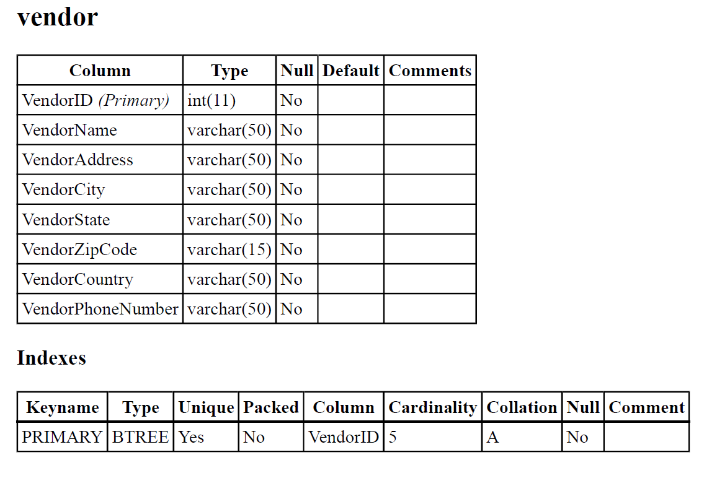

V. Database and SQL Queries

The queries that will be showcased for this project are the following:
1) Browse all customer information from the state of California.
2) Locate all customers whose first name starts with an M.
3) Retrieving all matching IDs from oder and shipment for customer orders.
4) Locate a customer and their information for a specific matching transaction.
5) Find the employee number, employee name, and employee city of the department with the largest number of employees.
6) Find the vendor ID, vendor name, and vendor country of the cotton product supplier.

Query 1 (Equi-Join):
Browse all customer information from the state of California.

SELECT CustomerID, FirstName, LastName, CustomerCity, CustomerCountry, CustomerPhoneNumber, CustomerState,CustomerZipCode
FROM customer
WHERE CustomerState = 'California'
ORDER BY CustomerID;
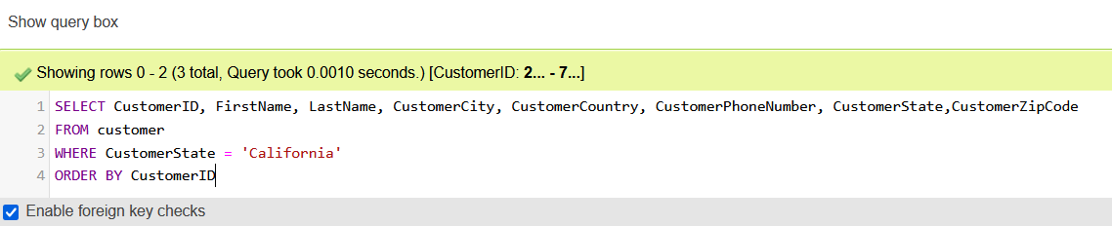

Query 1 Result:
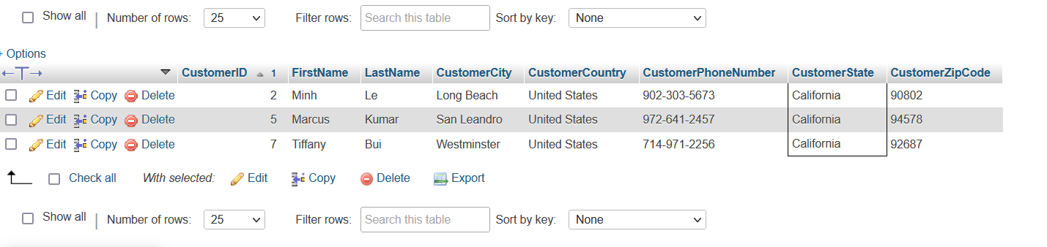
In this query, users can filter all of their customers who are from California. Because the company is based in California, this query will give the users a better idea of the number of customers in this specific state.

Query 2 (Using Alias):
Locate all customers whose first name starts with an M.

SELECT FirstName AS first, LastName AS last, CustomerAddress AS address
FROM customer
WHERE FirstName LIKE 'M%';
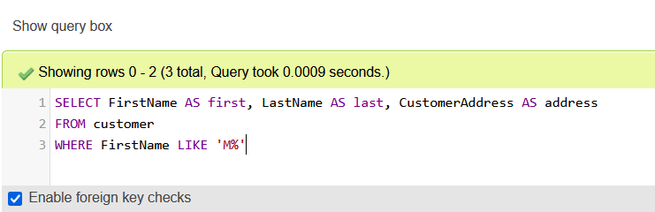

Query 2 Result:
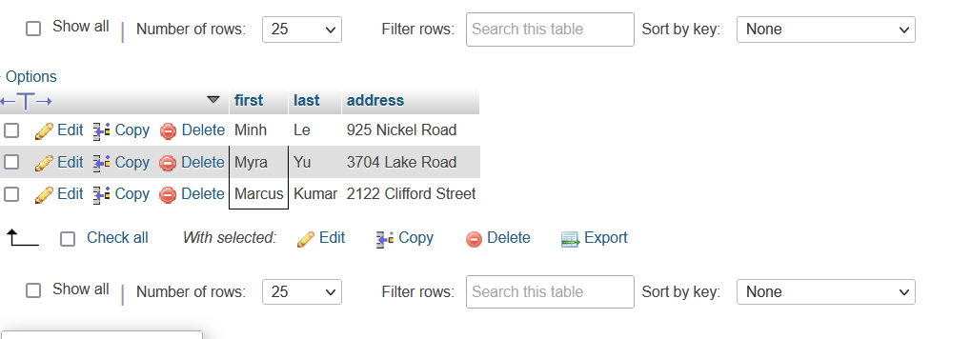
Using the LIKE operator in a WHERE clause helps users to find a specific pattern in a column. In this case, the query was trying to find all the customers who specifically have the first name starting with the letter “M”.

Query 3 (Inner Join):
Retrieving all matching IDs from oder and shipment for customer orders.
SELECT OrderDate, oder.OrderID, OrderQuantity, shipment.OrderID, shipment.DeliveryMethodID, ExpectedArrival, shipment.OrderID, ShipDate, ShipmentStatus, TrackingNumber
FROM oder INNER JOIN shipment
ON oder.OrderID = shipment.OrderID
ORDER BY oder.OrderID;
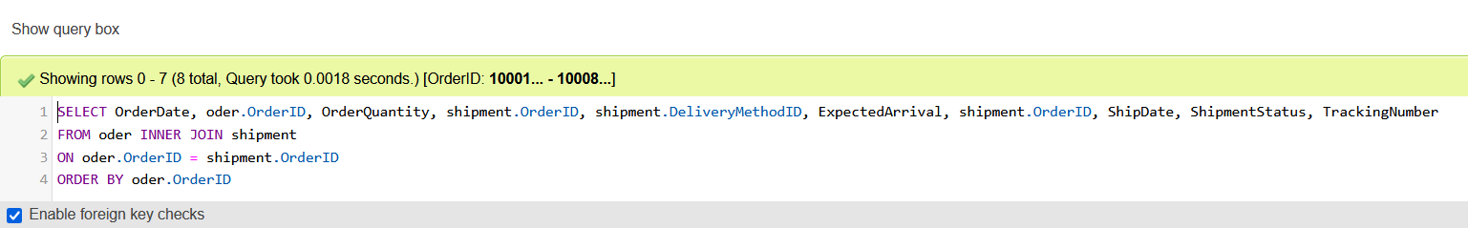
Query 3 Result:
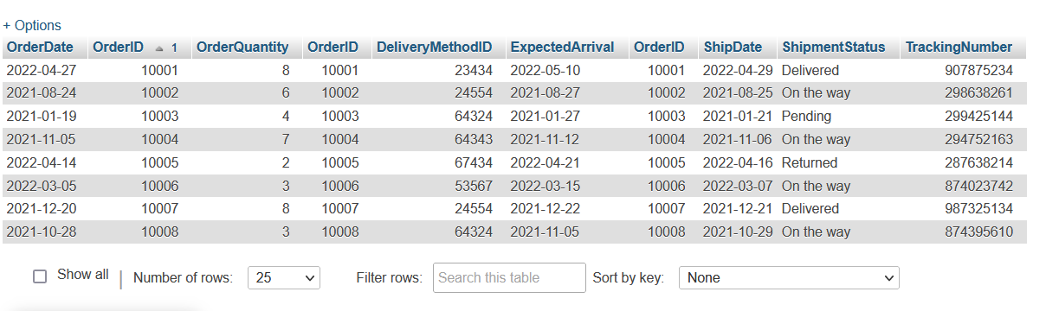
This query uses the inner join operator to combine the order table and shipment table in which both tables have the common value of “OrderID”. The query’s results give users a better understanding of each order and its shipping information.

Query 4 (Subquery):
Locate a customer and their information for a specific matching transaction.

SELECT FirstName, LastName, CustomerAddress, CustomerCity, CustomerCountry, CustomerID, CustomerPhoneNumber, CustomerState, CustomerZipCode
FROM customer
WHERE customerID =
(SELECT transaction.CustomerID
FROM transaction
WHERE CustomerID = 007);
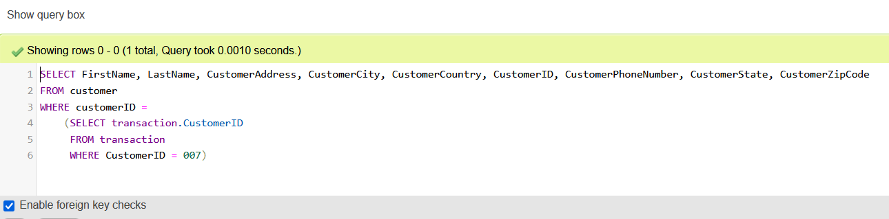

Query 4 Result:
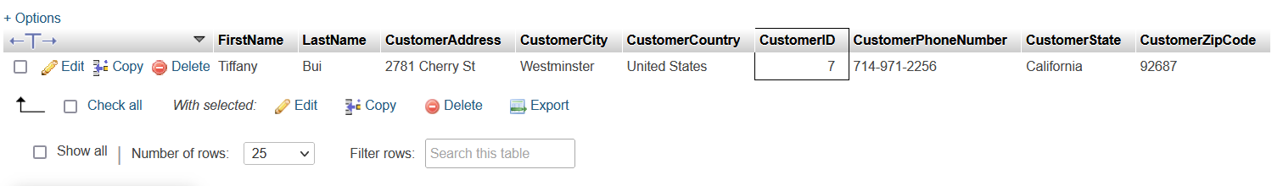
In this query, which has a subquery, the customer information is gathered from a customer whose ID matches a specific transaction.

Query 5 (Subquery):
Find the employee number, employee name, and employee city of the department with the largest number of employees.

SELECT EmployeeID,EmployeeName,Employeecity
FROM employee
WHERE DepartmentID =(SELECT DepartmentID FROM department
WHERE DepartmentCount = (SELECT max(DepartmentCount) FROM department))

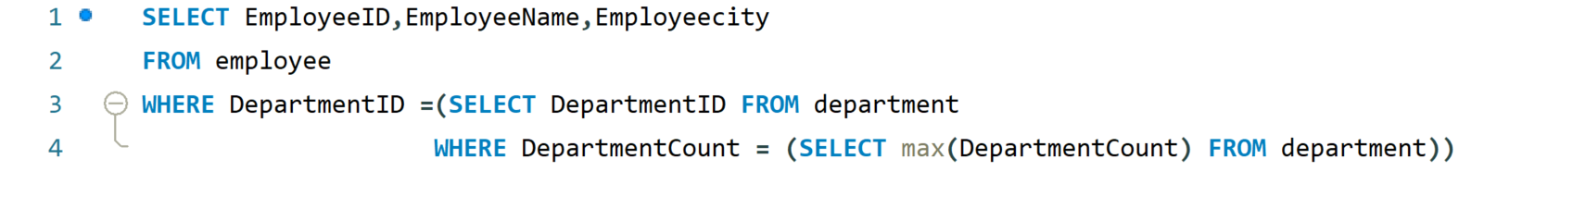
Query 5 Result:
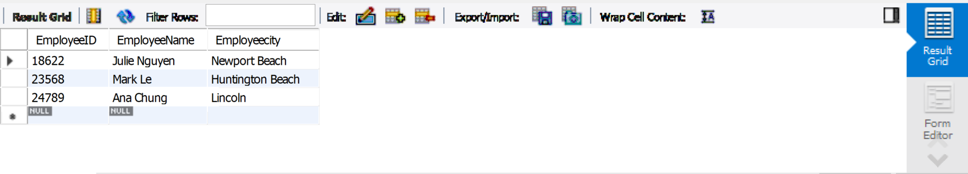
Using the subqueries, the users can identify which department in their company has the most employees.

Query 6 (Left Join):
Find the vendor ID, vendor name, and vendor country of the cotton product supplier.

SELECT vendor.VendorID,vendor.VendorName,VendorCountry
FROM supplies
LEFT JOIN suppliesline
ON supplies.MaterialID = suppliesline.MaterialID
LEFT JOIN vendor
ON vendor.VendorID = suppliesline.VendorID
WHERE supplies.MaterialName = 'Cotton'

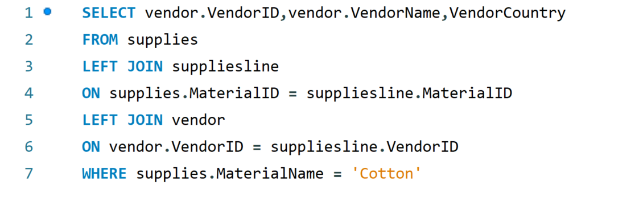
Query 6 Result:
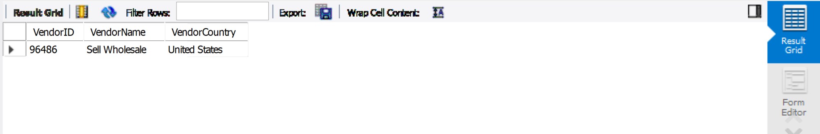
In this query, a LEFT JOIN is used to acquire data from supplies and suppliesline, matching on Material ID. It is also used on vendor and suppliesline, matching on vendor ID. The condition is that the material name of the supplies is cotton.

